# Example 1 Façade Design Pattern

# Example 2 Façade Design Pattern

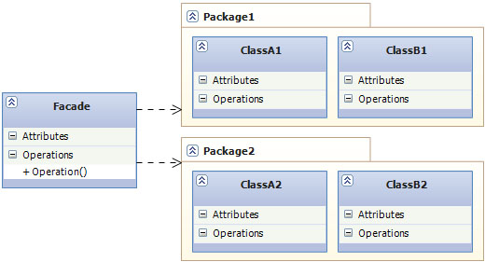

# Example 3 Façade Design Pattern

